**Pre-Lab 1 Report Alan Palayil A20447935**

ECE 100-00X

Prof. Oruklu Lab Date: 8/29/19

TA: Your TA Due Date: 8/29/19

**Problem Statement**

           To read the introductory chapter of basic programming of Interactive C and building a simple handy-bot robot which can avoid an obstacle while completing the maze.

**Investigation/Research**

           The chapter introduces the Interactive C programming. There are different program functions explained. The complete handy-bot board is explained. The programs such as to test the board, motors and the sensors provided are working will be tested. The building of the handy-bot with basic motor functions and we will try to make the handy-bot avoid an obstacle. To avoid an obstacle the basic idea is to place the sensors in front of the handy-bot and when the bot crashes on an obstacle, the bot such move backward then turn in order to avoid the obstacle and move forward.

**Alternative Solutions**

            The flowcharts are provided.

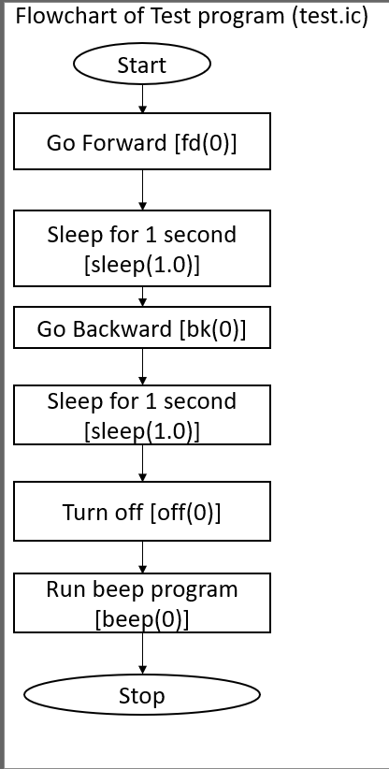

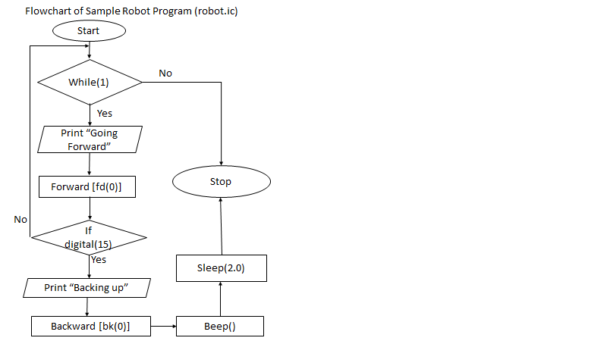

**Optimum Solution**

       The most optimum solution for the handy-bot to avoid an obstacle. The solution involves the handy-bot to move forward as long as there is no obstacle in front of it. When an obstacle is in front of the handy-bot and the analog sensor gets activated and the handy-bot stops, moves backwards then later will change its direction slowly and then moves forward and in turn should prevent the obstacle.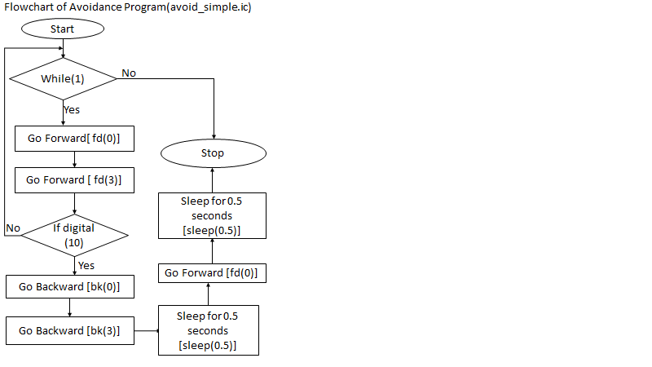

**References**

1.  Martin, Fred G. 2001. *Robotic Explorations: A Hands-On Introduction to Engineering*. New Jersey: Prentice Hall.

2.  Oruklu, Erdal. 2015. *ECE 100* *Lecture Notes*. Chicago: Illinois Institute of Technology, Electrical and Computer Engineering Department.

**Appendix**

            /* sample touch sensor program*/

void main ()

{

while (1)

{

/* go forward*/

fd (0);

fd (3);

/* test for touch*/

if (digital (10))

{

/* go backward*/

bk (0);

bk (3);

sleep (0.5);

/*turn*/

fd (0);

sleep (0.5);

}

}

}